**AWS Task-5**

**Task Description:**

Deploy a simple web application using AWS code commit, code build and deploy & access via browser and automate via codepipeline.

**Techstacks needs to be used :**

* AWS CI-CD (CodeCommit, CodeBuild, CodeDeploy, CodePipeline).

**Steps:**

1. Launching an EC2

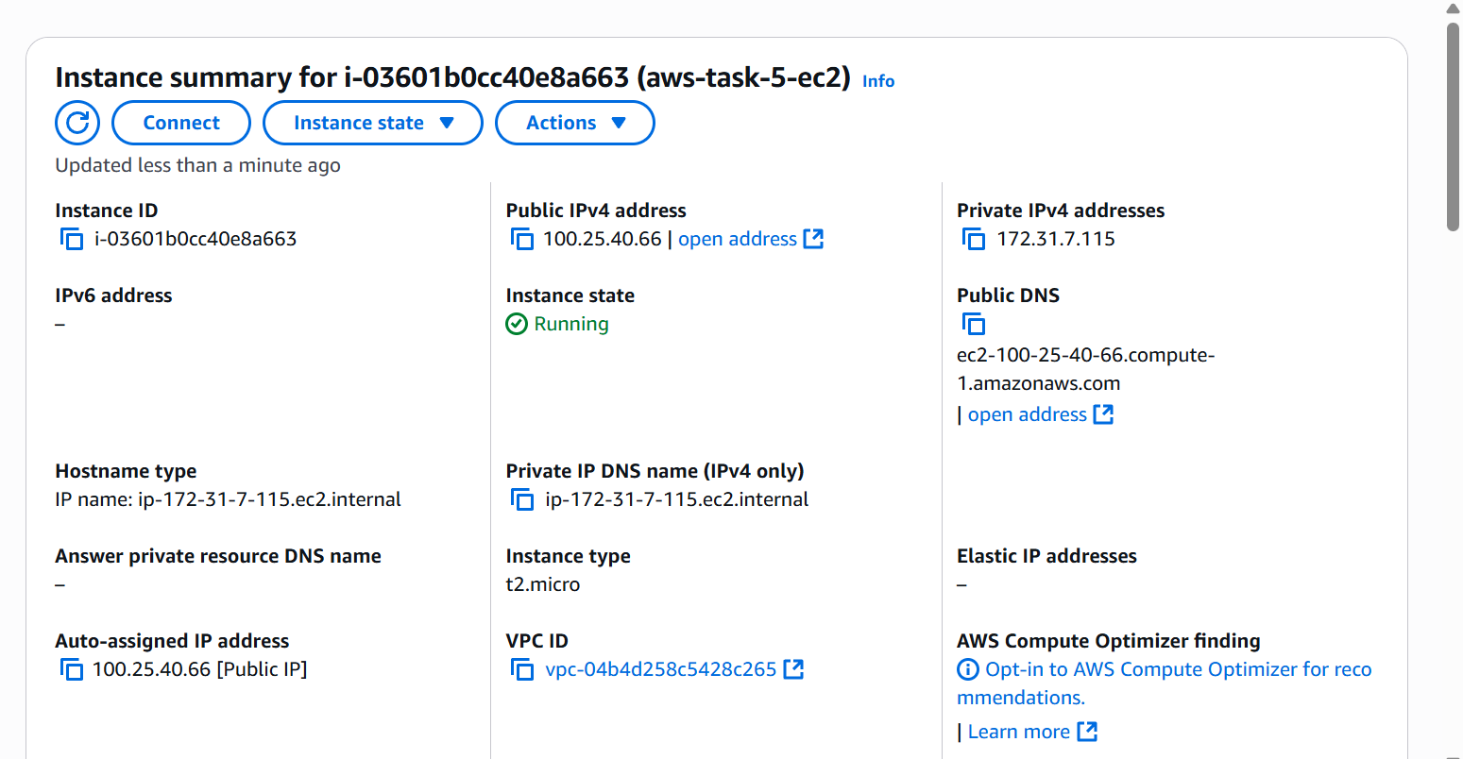

Added ssh access and http access( to view deployed app) in the SG of the instance

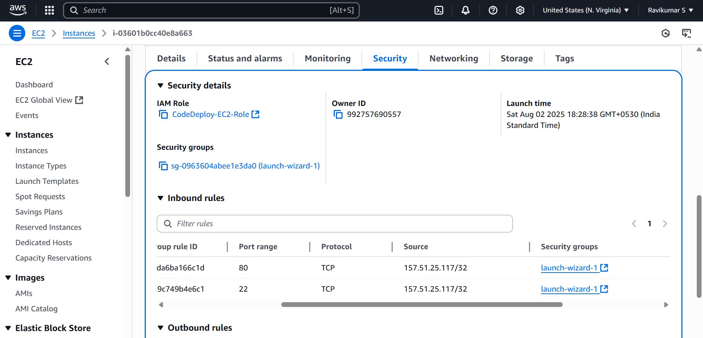

1. Install required packages

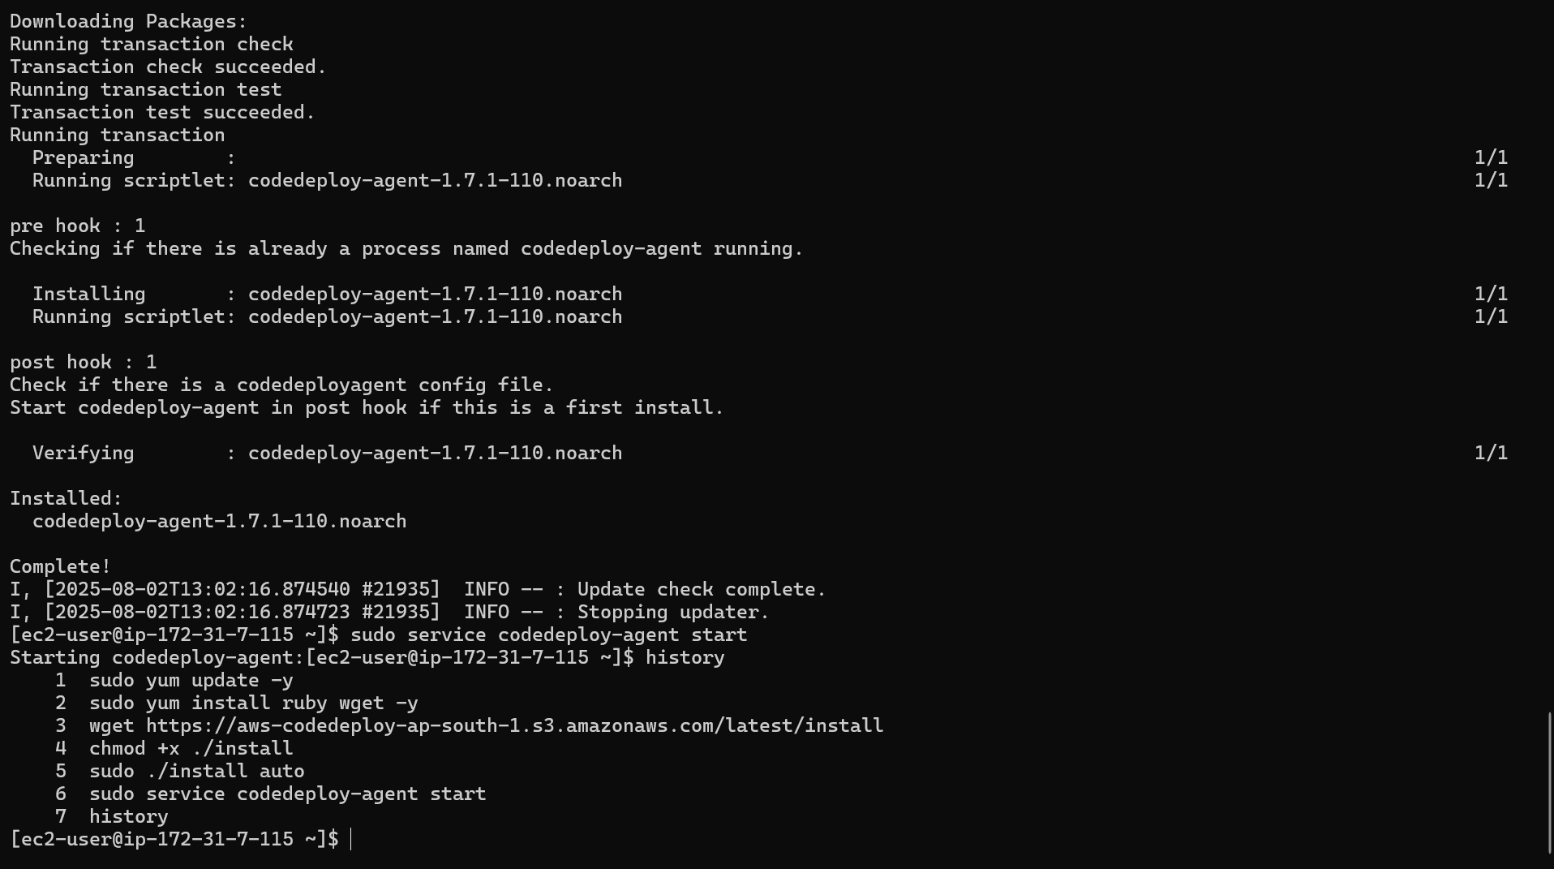

1. Created necessary IAM roles

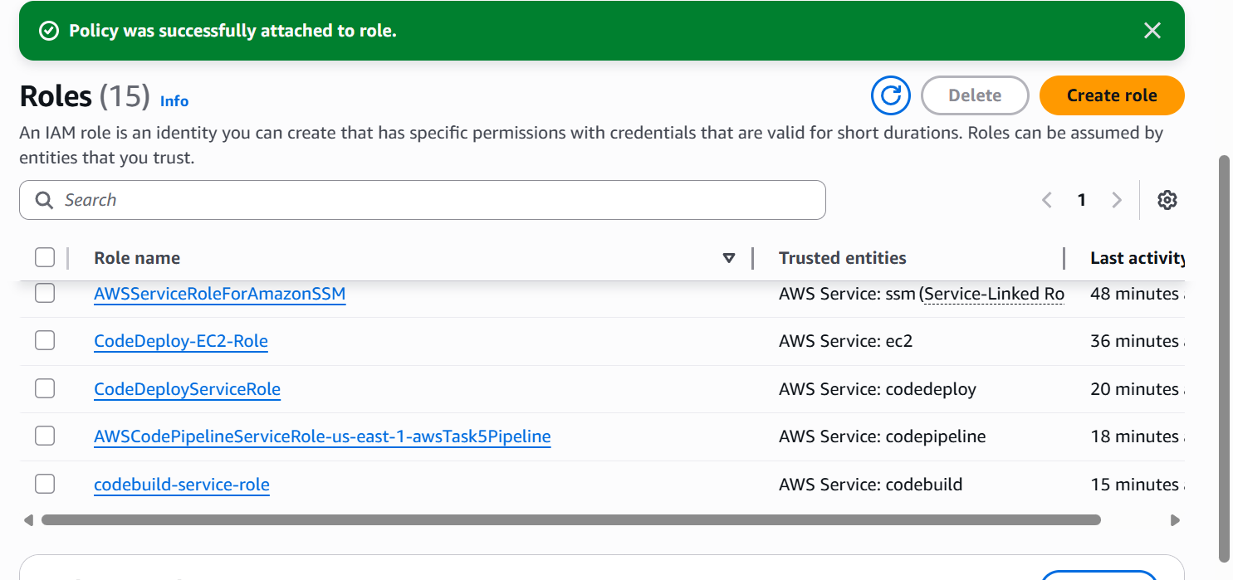

1. Created CodeDeploy application

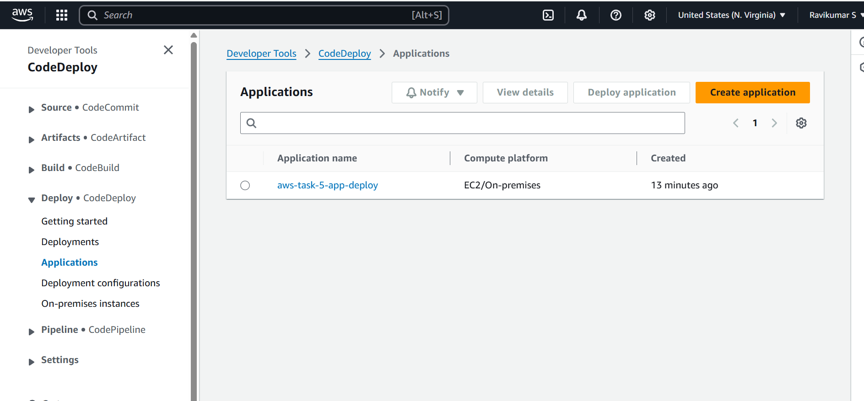

1. Created deployment group inside CodeDeploy application

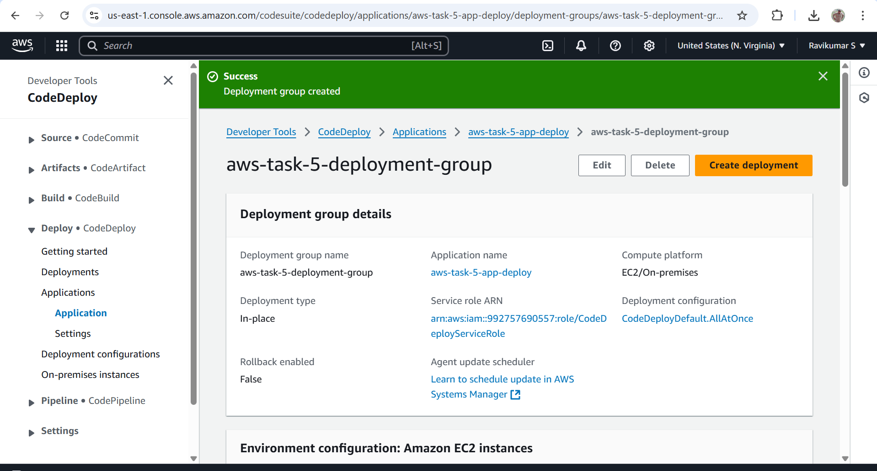

1. Created codeBuild project

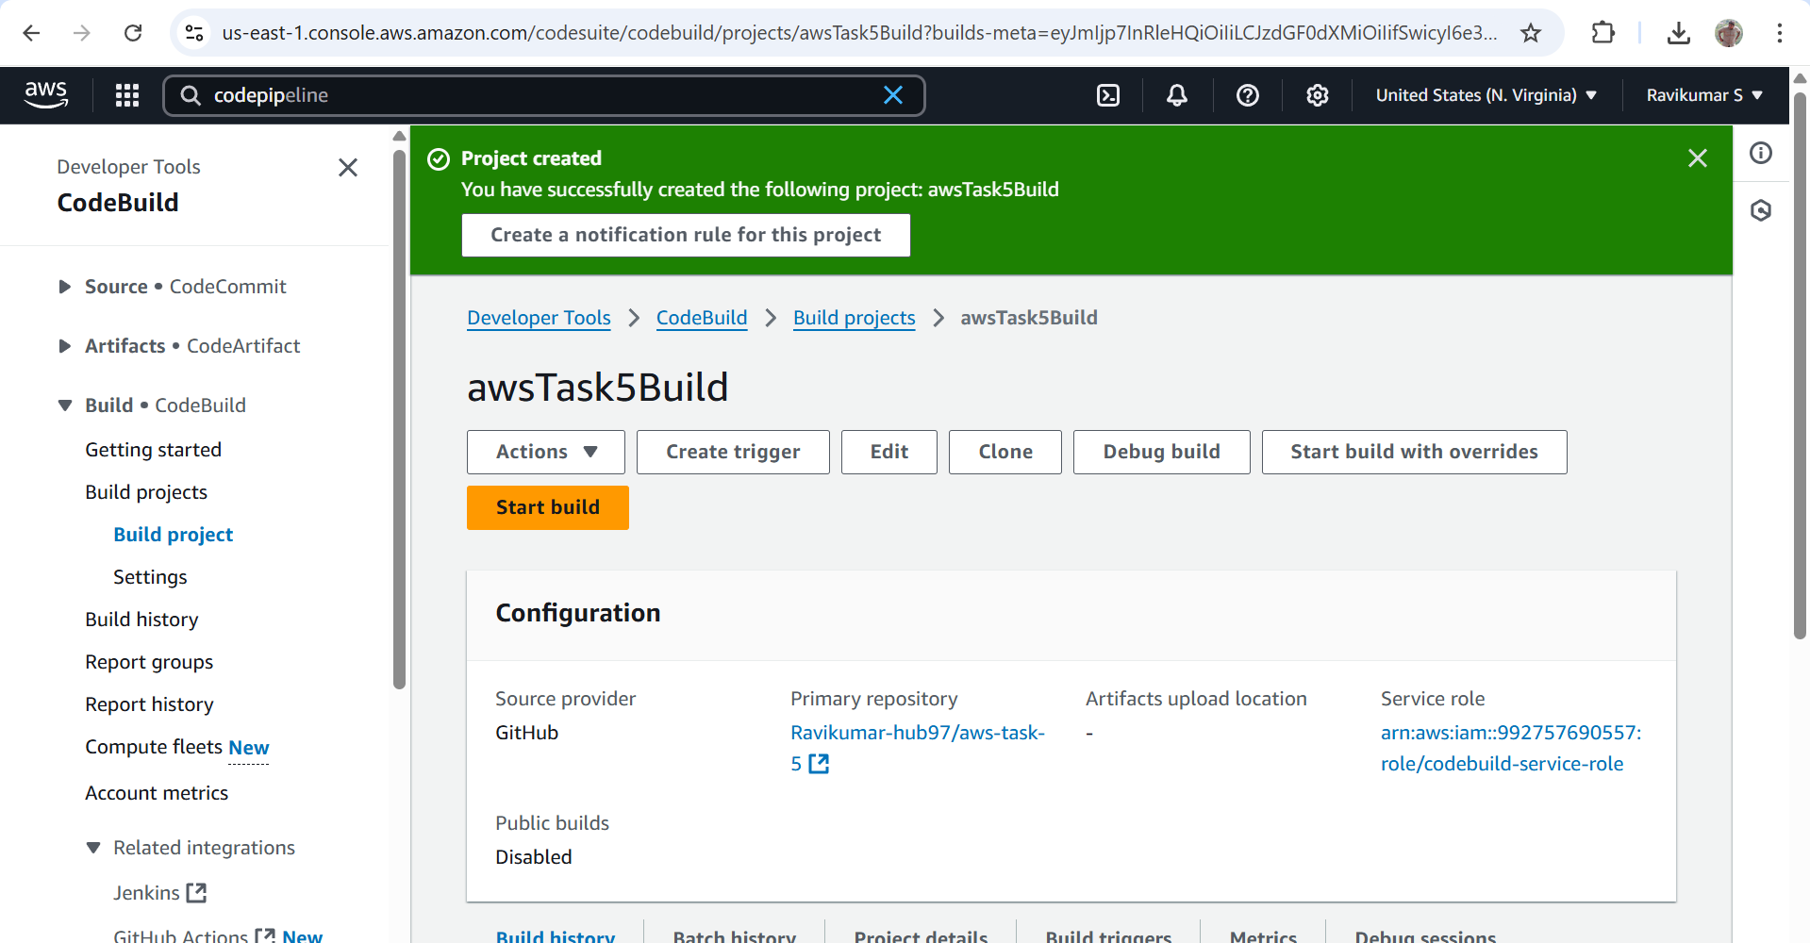

1. Created codePipeline

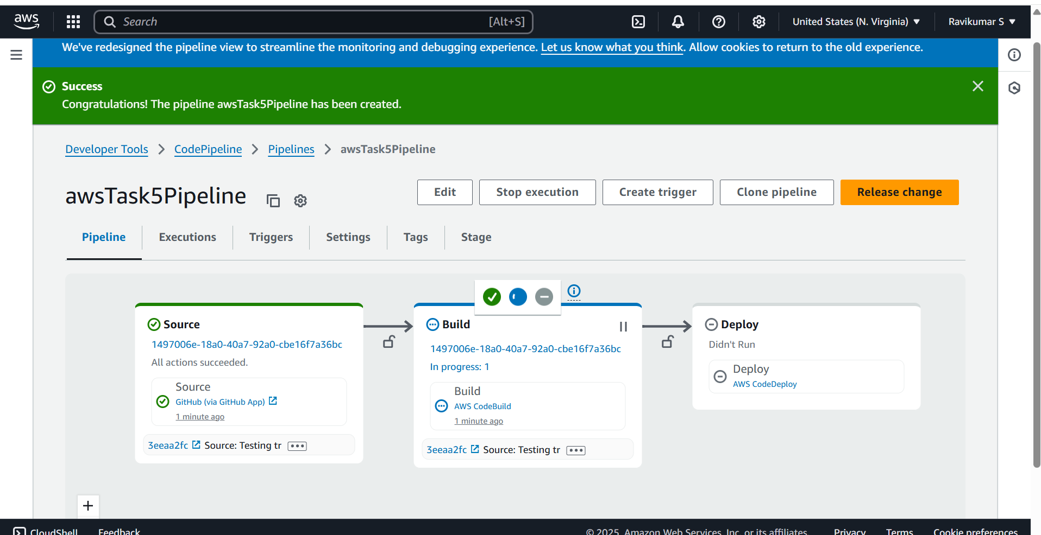

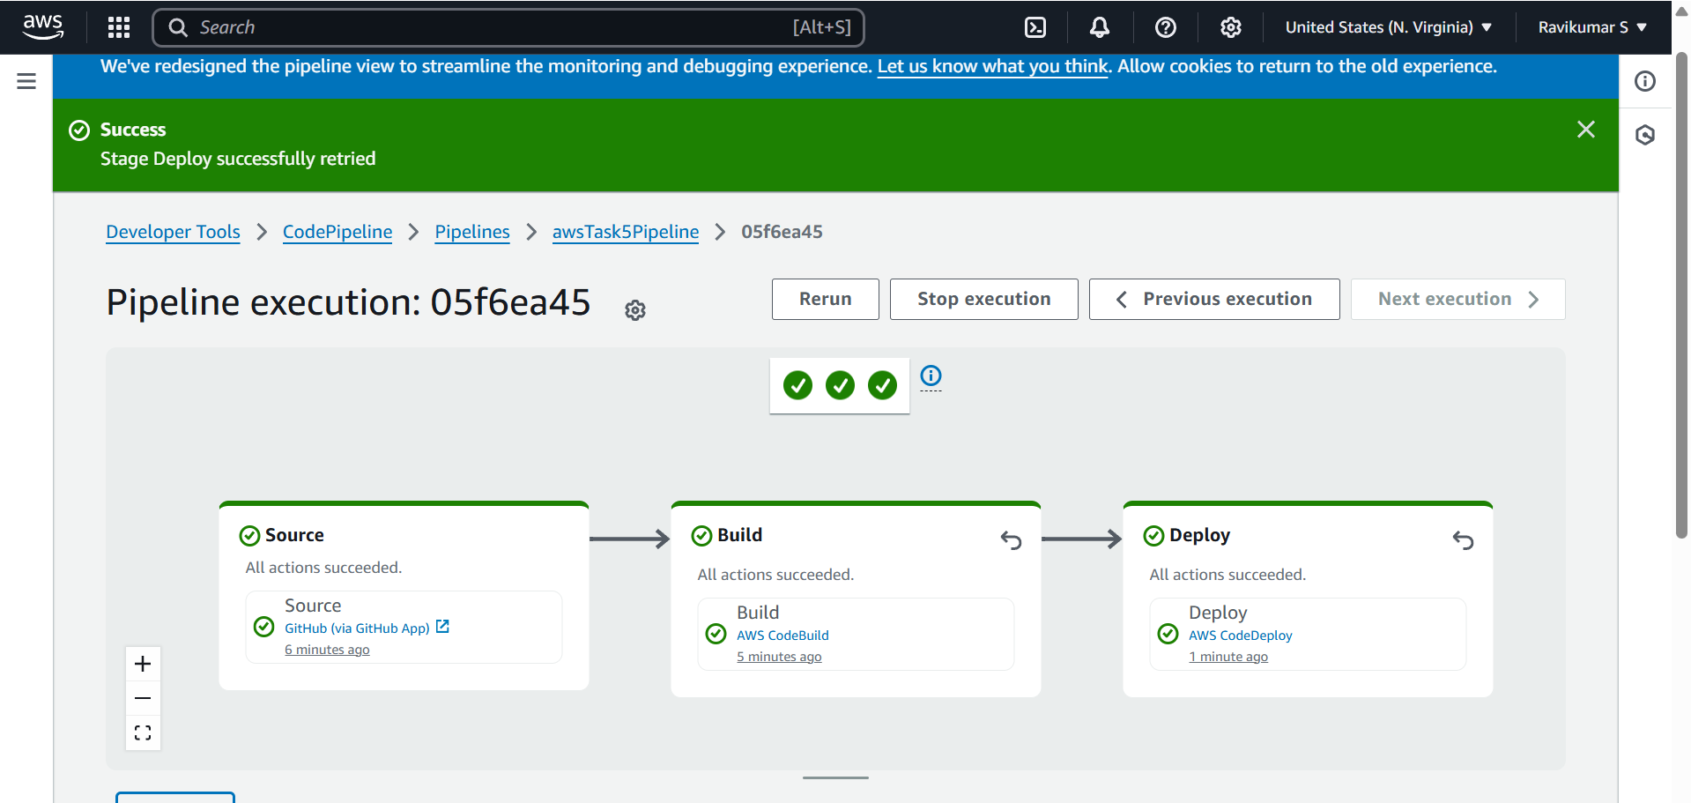

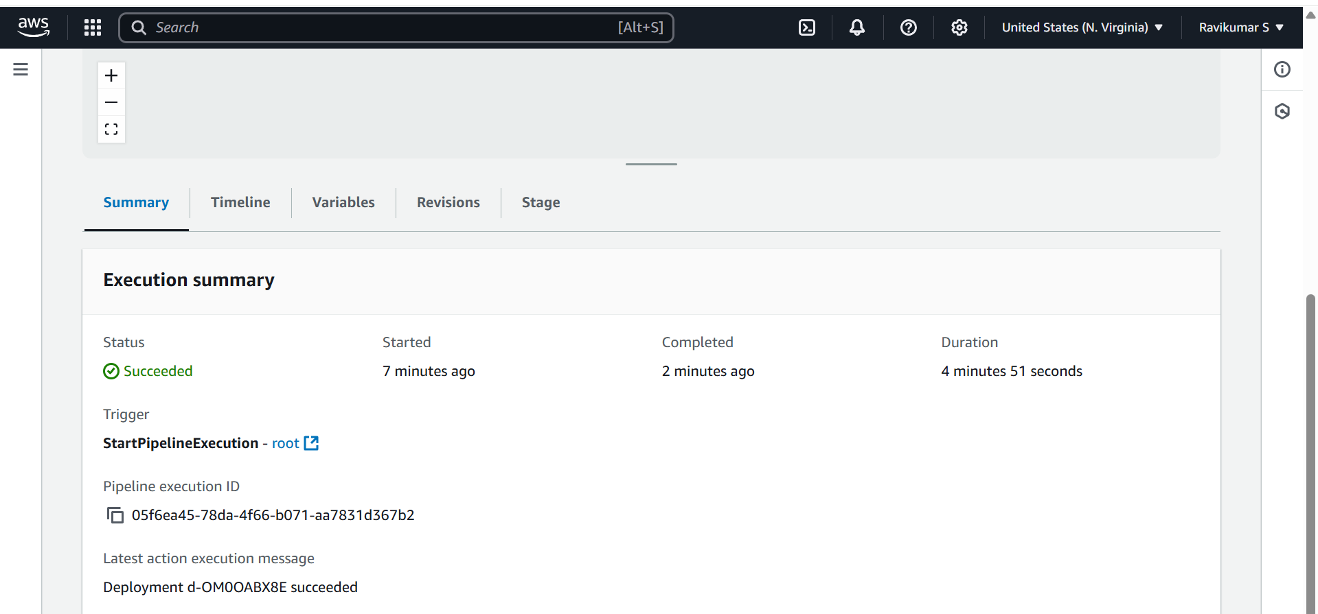

App deployed

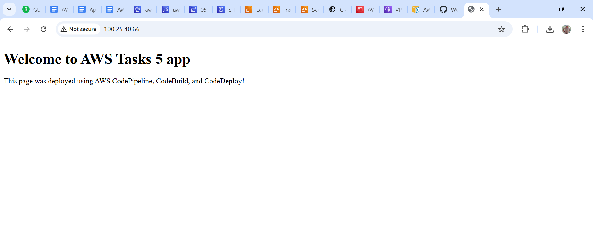

Testing automatic deployment with another update

